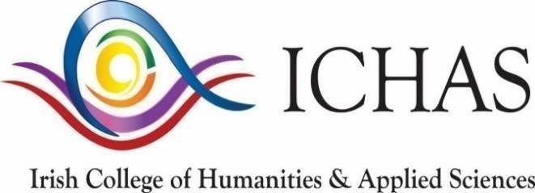

The Irish College of Humanities and Applied Sciences would like to make your members aware of funding opportunities available for a QQI Level 9 Postgraduate Certificate in Addiction Studies(Gambling)

Supported by the Gambling Awareness Trust (GAT) The college has secured funding for 70% of fees for 30 places on this certificate programme commencing in February 2024.
The current funding from the Gambling Awareness Trust is for €1900 of the €2400 – the way in which the funding works is the student pays ICHAS the €2400 and then once the student successfully completes the programme ICHAS refunds €1900 paid by the Gambling Awareness Trust.

Further information including schedules and module information can be found at https://ichas.ie/course/certificate-in-addiction-studies-gambling/

Applications can be made at https://myichas.ie/newApplication/apply

If you have any question or need further information, please do not hesitate to contact me or if you have anybody that might be interested they can contact me directly at tony.obrien@ichas.ie

